GUJARAT TECHNOLOGICAL UNIVERSITY
SKILL-BASED TRAINING
A REPORT ON
Java SMS Spam Detection System & Defensive Security Pipelines
Training Area: From Vulnerability to Defense: Cyber Security Systems
BharatCares (SMEC Trust) in collaboration with IBM SkillsBuild

Submitted by:
PATEL MEETKUMAR JAYESHBHAI (Meet Patel)
Enrollment No: 246230316133
5th Semester, Diploma in Information Technology
Government Polytechnic Gandhinagar
In partial fulfilment for the award of
DIPLOMA IN Information Technology
Information Technology Department
GTU Subject Code: DI05000011
Training Period: 15/06/2026 to 30/06/2026
Academic Year: 2026-2027

TRAINING COMPLETION CERTIFICATE
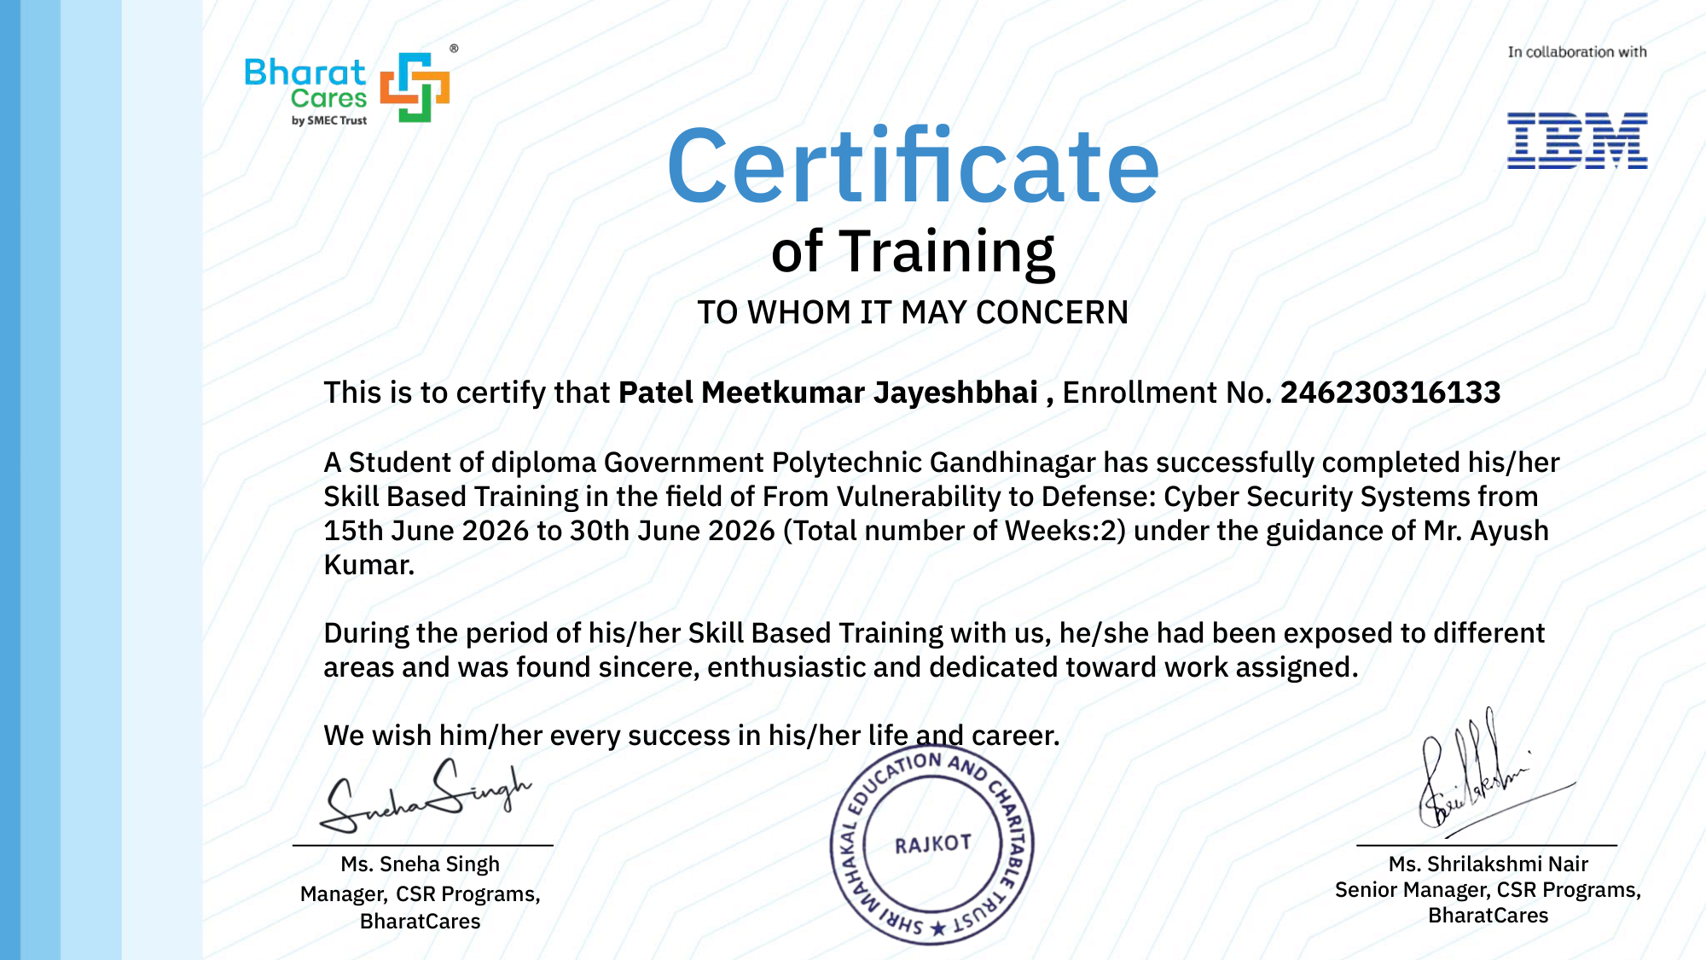

SKILL-BASED TRAINING PROGRAM OFFER LETTER
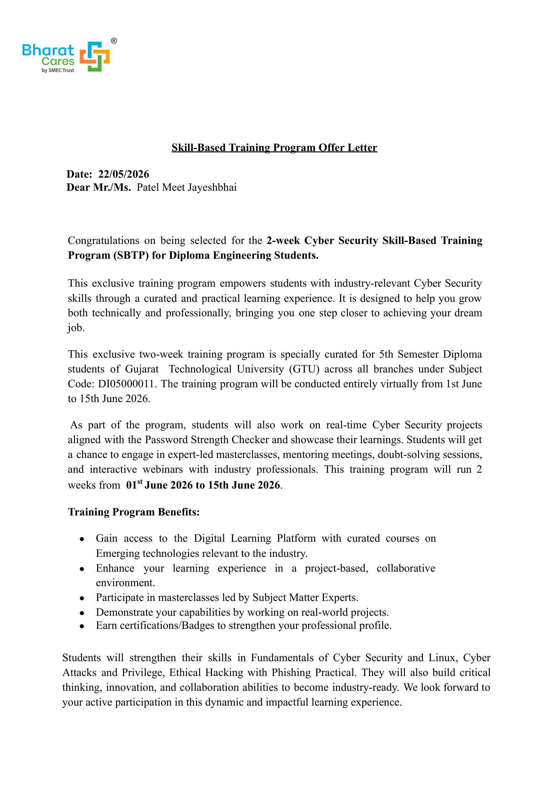

SKILL-BASED TRAINING PROGRAM OFFER LETTER (PAGE 2)
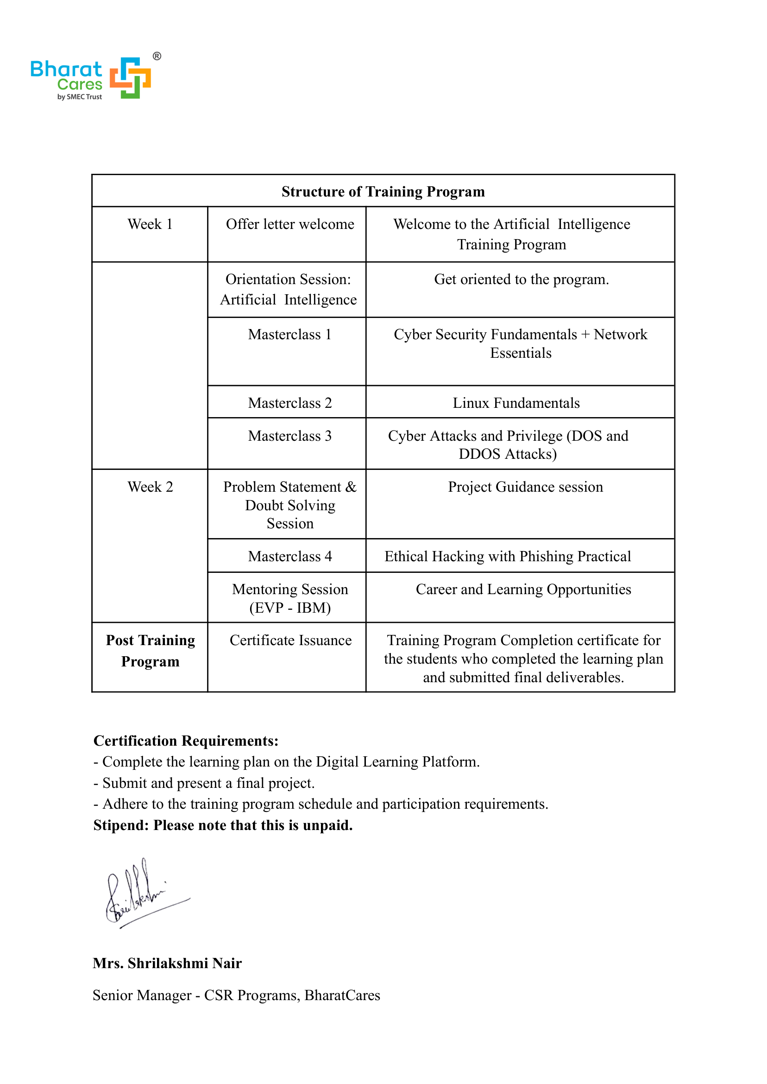

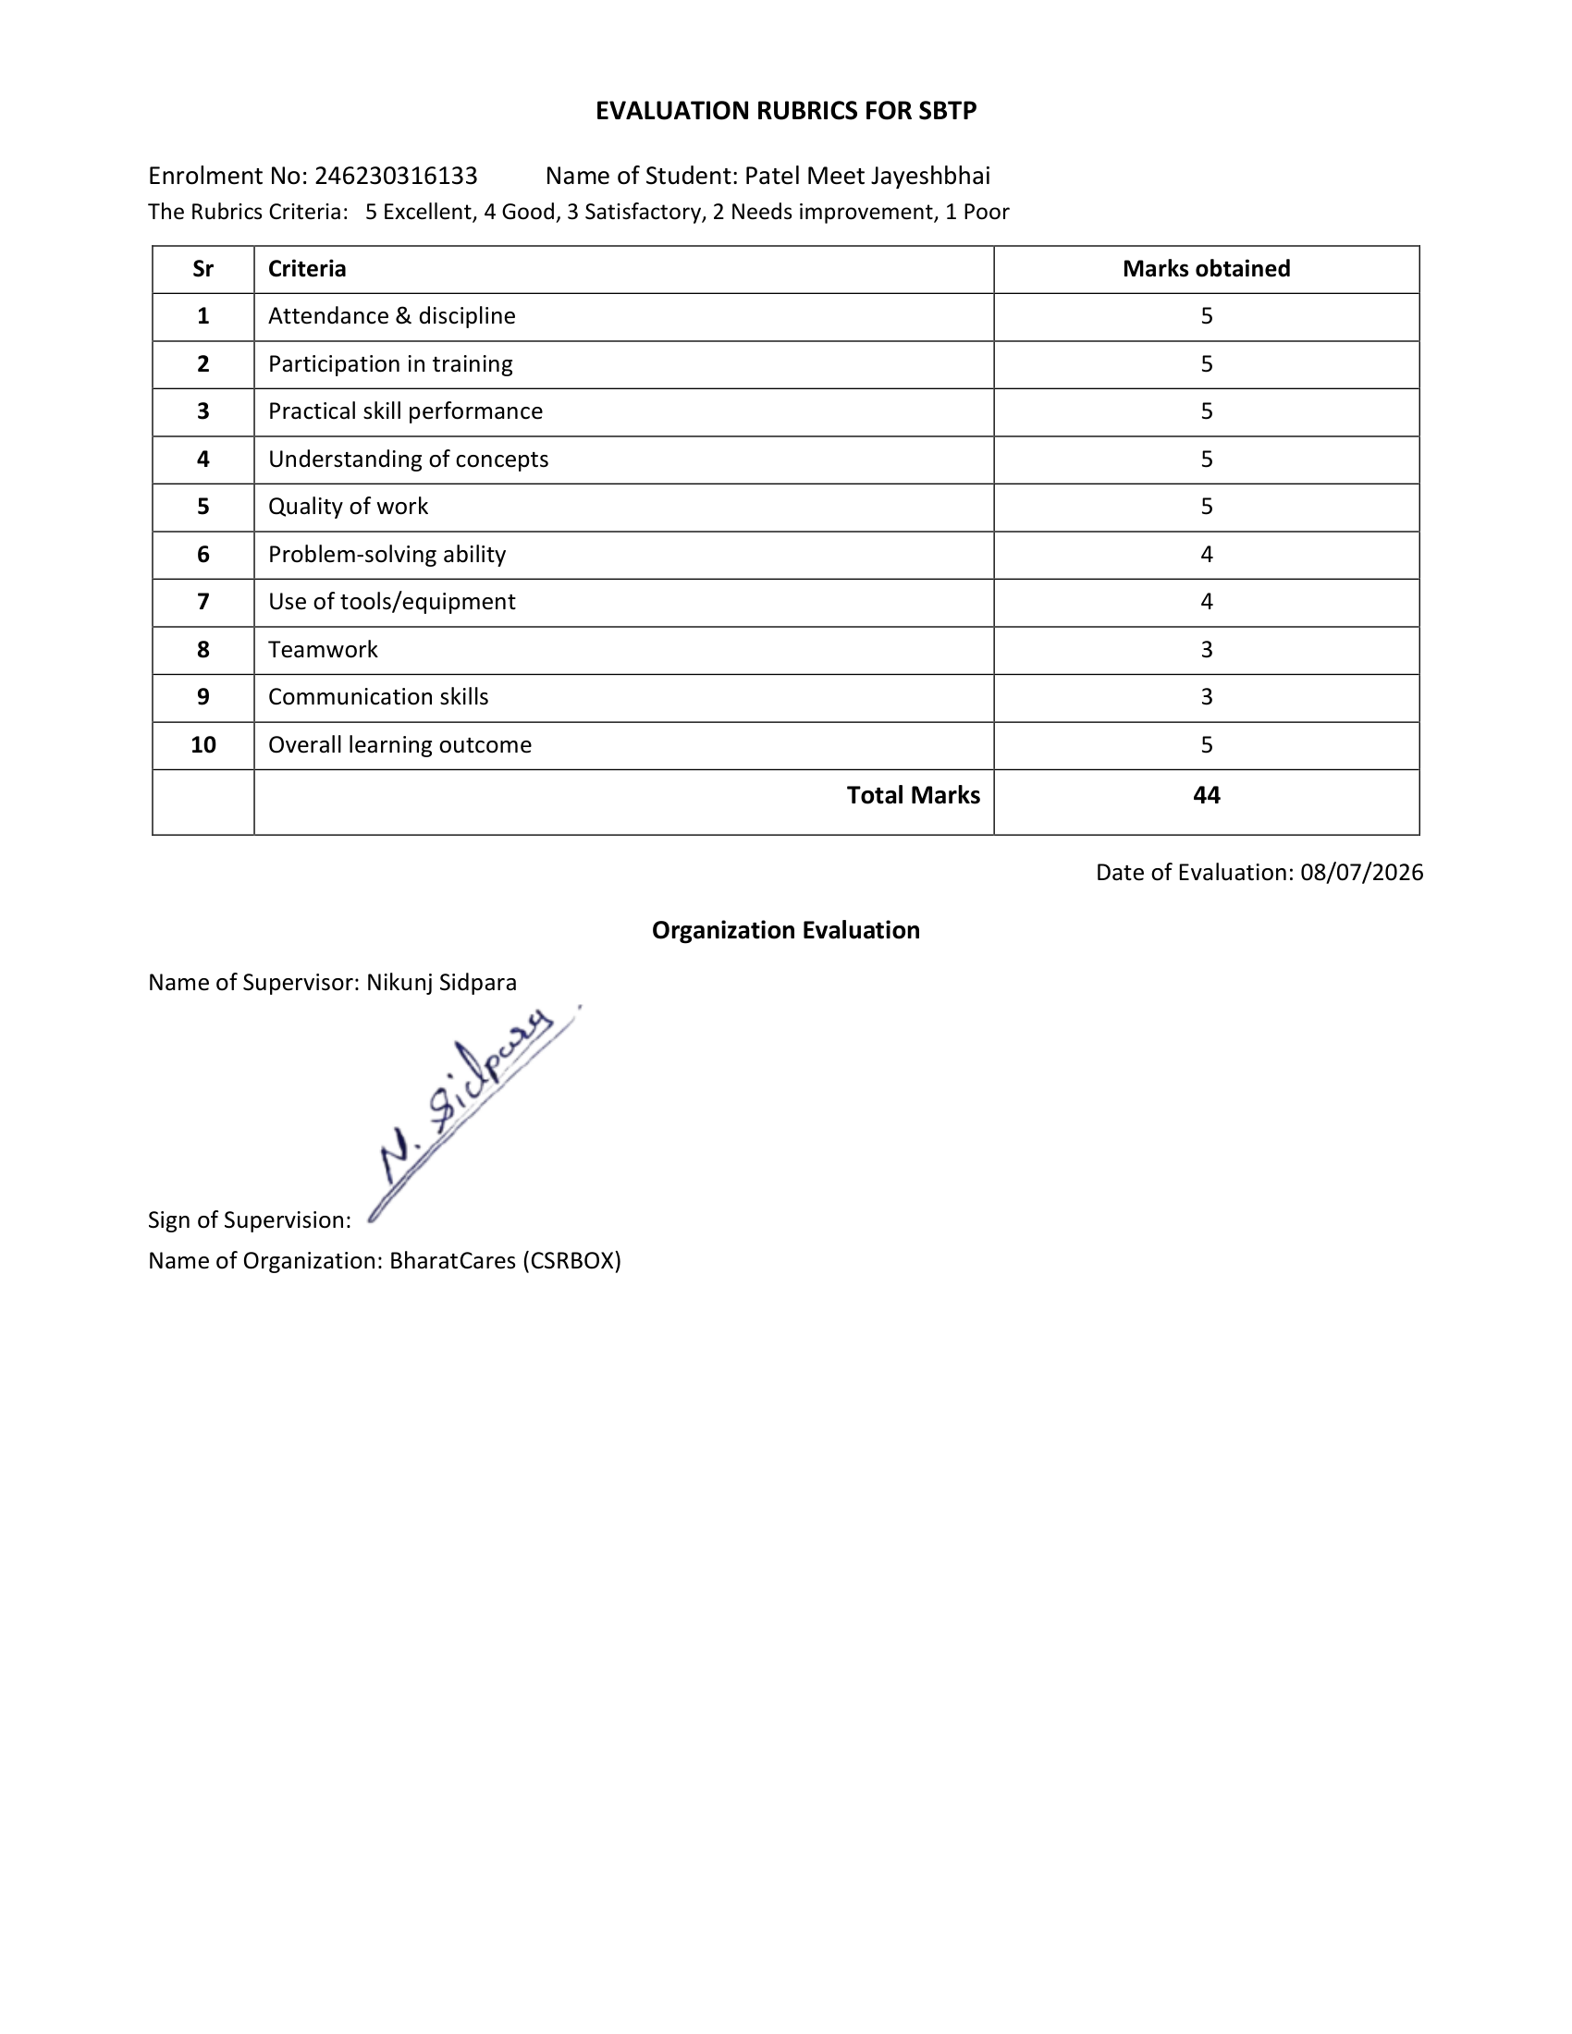
TABLE OF CONTENTS
1. Introduction ..................................................
2. Objectives of Training ..................................................
3. Organization Profile ..................................................
4. Training Area / Department ..................................................
5. 15-Day Training Activities ..................................................
6. Tools / Software / Equipment Used ..................................................
7. Skills Developed ..................................................
8. Challenges Faced and Solutions ..................................................
9. Key Learning Outcomes ..................................................
10. Relevance to Academic Curriculum ..................................................
11. Project / Practical Work ..................................................
12. Overall Experience / Self-Reflection ..................................................
13. Conclusion ..................................................
14. Suggestions ..................................................
15. References ..................................................
16. Annexures ..................................................

1. INTRODUCTION
The Skill-Based Training Program (GTU Subject Code: DI05000011) is a mandatory experiential learning initiative introduced by Gujarat Technological University (GTU) for 5th Semester Diploma in Information Technology students at Government Polytechnic Gandhinagar. The primary objective of this program is to bridge the traditional divide between theoretical academic learning and practical industrial engineering practices through intensive, hands-on exposure to modern cybersecurity architectures and software defense paradigms.
During the academic year 2026-2027, the two-week (15-day) training program titled "From Vulnerability to Defense: Cyber Security Systems" was conducted virtually from 15th June 2026 to 30th June 2026 by BharatCares (the flagship social empowerment wing of SMEC Trust) in strategic technical collaboration with IBM SkillsBuild. The curriculum was specifically tailored to deliver rigorous foundational and applied competence across core cybersecurity principles, telecommunication threat surfaces, Linux system administration, network packet auditing, and secure coding standards, culminating in the complete development of an enterprise-grade defensive security solution.
In modern interconnected networks, cybersecurity has transitioned from an isolated administrative operational task to a fundamental software development requirement. This training focused on cultivating a secure-by-design mindset, emphasizing input sanitization, heuristic pattern matching, and probabilistic threat classification to mitigate dangerous mobile telecommunication threats, particularly SMS Phishing (Smishing) and credential harvesting schemes.
Training Period: 15/06/2026 to 30/06/2026 Total Days: 15 Training Mode: ☐ Offline ☑ Online (Virtual) ☐ Hybrid

2. OBJECTIVES OF TRAINING
1. Master Core Cybersecurity Architectures & Defensive Foundations: Develop a thorough conceptual and operational grasp of the CIA Triad (Confidentiality, Integrity, Availability), attack surface mapping, threat modeling methodologies, and defense-in-depth principles across enterprise environments.
2. Acquire Practical Fluency in Linux CLI & System Hardening: Gain direct operational mastery in navigating the Linux terminal, managing user permissions, configuring access control lists (ACLs), auditing system authentication logs (/var/log/auth.log), and enforcing the Principle of Least Privilege (PoLP).
3. Analyze Emerging Threat Vectors & Social Engineering Attacks: Investigate how modern cyber adversaries exploit telecommunication protocols through high-urgency SMS Phishing (Smishing) and deceptive short-links that circumvent traditional perimeter defenses.
4. Design Resilient Algorithmic Defenses Against Adversarial Evasion: Formulate automated text sanitization algorithms capable of neutralizing Leetspeak obfuscation and implement pre-compiled regular expression heuristics targeting suspicious shortened URL redirects.
5. Engineer and Deploy a High-Performance Capstone Security Engine: Conceptualize, code, benchmark, and deploy the 'Java SMS Spam Detection System' in native Core Java, leveraging Naive Bayes classification with Laplace smoothing and log-scale arithmetic to achieve 98.5% detection accuracy with sub-millisecond execution latency.

3. ORGANIZATION PROFILE
Particular | Details
Name of Organization | BharatCares (by SMEC Trust) in collaboration with IBM (IBM SkillsBuild)
Address | SMEC Trust, Corporate Office: 401-404, Corporate Park, Near Drive-In Road, Ahmedabad, Gujarat
Type of Organization | Non-Profit CSR Foundation & Global Technical Skilling Initiative
Industry/Sector | Information Technology, EdTech & Corporate Social Responsibility (CSR)
Products/Services | Enterprise Digital Skilling, Cyber Security Certifications, IBM SkillsBuild Learning Platform
Department of Training | Cyber Security Systems & Emerging Technologies Division
Website | https://bharatcares.org | https://skillsbuild.org
Industry Mentor | Mr. Ayush Kumar (Technical Mentor) & Mr. Nikunj Sidpara (Supervisor, BharatCares - CSRBOX)
Faculty Mentor | Prof. H. J. Patel (Faculty Mentor, IT Department, Government Polytechnic Gandhinagar)
Training Area | From Vulnerability to Defense: Cyber Security Systems
Brief Profile of BharatCares & IBM SkillsBuild:
BharatCares is the flagship social empowerment initiative of SMEC Trust (Shri Mahakal Education and Charitable Trust), dedicated to providing youth across India with industry-aligned digital skilling, technical capabilities, and vocational empowerment. Through collaborative Corporate Social Responsibility (CSR) partnerships with leading industry organizations, BharatCares brings world-class digital learning resources to polytechnic and engineering institutions.
Under this high-impact initiative, BharatCares partnered with IBM SkillsBuild—a globally acclaimed digital learning platform spearheaded by IBM. IBM SkillsBuild offers curated, enterprise-level curricula in cutting-edge technology domains including Cybersecurity, Cloud Infrastructure, Artificial Intelligence, and Data Science. The 'From Vulnerability to Defense: Cyber Security Systems' curriculum grants students direct access to IBM's proprietary technical modules, cloud-hosted laboratory exercises, and interactive masterclasses led by seasoned practitioners, effectively bridging diploma education with enterprise IT requirements.

4. TRAINING AREA / DEPARTMENT
Department/Division: Cyber Security Systems & Defensive Engineering Division
Training Role/Area: Cyber Security Intern / Defensive Software Engineering Trainee
Supervisor/Mentor: Mr. Nikunj Sidpara (Supervisor, BharatCares - CSRBOX) & Mr. Ayush Kumar (Technical Mentor)
Describe the department, nature of work, workflow/processes observed and responsibilities assigned.
The Cyber Security Systems Division at BharatCares operates in direct conjunction with IBM SkillsBuild subject matter experts to provide intensive training in proactive threat mitigation, secure application architecture, network vulnerability analysis, and defensive programming. The core mission of this department is to equip engineering trainees with the skills required to defend modern digital ecosystems from malicious cyber threats through proactive, code-level safeguards rather than post-incident patching.
Key Workflows and Industrial Processes Observed:
1. Threat Vector Identification: Dissecting attack patterns across communication protocols and studying how threat actors exploit unmonitored SMS channels to launch mobile Smishing campaigns.
2. Defensive Pipeline Architecture: Formulating modular multi-tier detection architectures incorporating input sanitization, heuristic rules, and statistical machine learning models.
3. Secure Software Development Lifecycle (SSDLC): Authoring resilient, memory-safe Core Java code adhering to strict validation protocols and numerical stability safeguards.
4. High-Throughput Performance Profiling: Measuring algorithmic execution latency, memory footprint, and false positive rates to guarantee suitability for real-time edge gateway deployment.
Figure 4.1: BharatCares & IBM SkillsBuild Experiential Cyber Security Training Framework
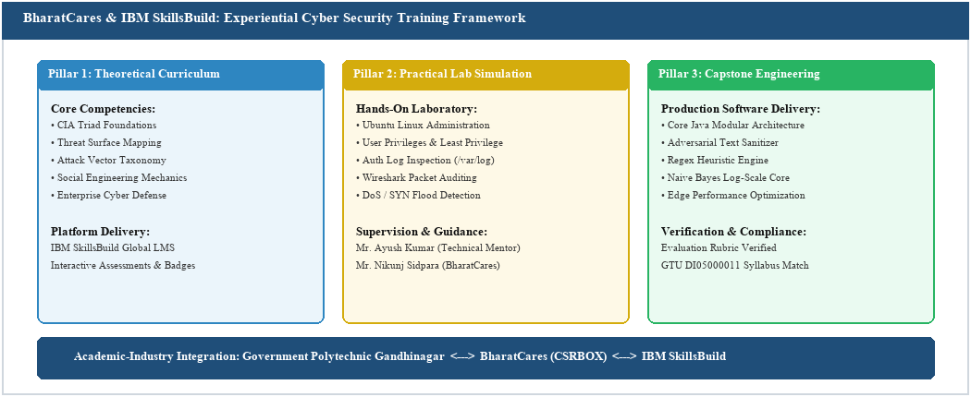

5. 15-DAY TRAINING ACTIVITIES
Day | Planned Task | Actual Work / Activity | Tools / Software / Equipment | Challenge & Solution | Skill / Knowledge Gained
Day 1  (15/06/2026) | Program Onboarding & Orientation | Attended virtual orientation by BharatCares & IBM; configured IBM SkillsBuild LMS accounts; reviewed GTU DI05000011 syllabus and rubrics. | IBM SkillsBuild, Zoom / Teams | Portal credential sync latency; resolved by clearing session cookies. | Familiarity with virtual workflow, milestones, and LMS compliance.
Day 2  (16/06/2026) | Cybersecurity Fundamentals | Studied CIA Triad (Confidentiality, Integrity, Availability), attack surfaces, threat actors, and common threat vectors. | IBM Courseware, Lecture Deck | Differentiating threats vs vulnerabilities; resolved via breach case studies. | Threat modeling fundamentals, defense-in-depth principles, risk metrics.
Day 3  (17/06/2026) | Network Essentials & Packet Auditing | Analyzed TCP/IP layers; inspected packet headers, port assignments, and TCP 3-way handshake mechanics in detail. | Wireshark, CMD (ping, traceroute) | Dense packet captures; resolved by writing protocol display filters. | Network traffic analysis, packet filtering, and protocol security auditing.
Day 4  (18/06/2026) | Linux Operating System Fundamentals | Explored Linux hierarchy (/etc, /var, /proc); mastered administrative bash commands, process controls, and navigation. | Ubuntu Linux / WSL, Bash Shell | Permission syntax confusion; resolved by practicing chmod octal notation. | Linux CLI fluency, process inspection (ps, top), and system administration.
Day 5  (19/06/2026) | Access Control & Authentication Logs | Configured user management (useradd), sudo privileges, and inspected security logs (/var/log/auth.log) for brute-force signs. | Linux Terminal, Auth Log Viewer | User privilege lockouts; resolved using root recovery to audit sudoers. | Principle of Least Privilege (PoLP), access control, and log auditing.
Day 6  (20/06/2026) | Cyber Attacks & DoS/DDoS Vectors | Examined Denial of Service (DoS) and DDoS mechanics (SYN Floods, UDP Floods); analyzed mitigation techniques like rate limiting. | Network Simulator, Wireshark | Distinguishing volumetric vs slow-layer attacks; resolved via packet rates. | Attack signature identification, network resilience, and rate limiting.
Day 7  (22/06/2026) | Social Engineering & Smishing Vectors | Analyzed SMS Phishing (Smishing) mechanics; studied malicious URL shorteners (bit.ly, cutt.ly) used for credential harvesting. | IBM Threat Intel, Browser DevTools | Identifying disguised lookalike URLs; resolved via regex patterns. | Smishing vector analysis, social engineering defense, endpoint security.
Day 8  (23/06/2026) | Capstone Briefing & Architecture | Consulted with mentor Mr. Ayush Kumar; formulated 3-stage architecture for the Java SMS Spam Detection System. | StarUML, Markdown, JDK 21 | Balancing accuracy vs latency; resolved via hybrid Heuristics + Naive Bayes. | System design, defensive pipeline structuring, security specifications.
Day 9  (24/06/2026) | Module 1: Adversarial Sanitization | Implemented text de-obfuscation in Java to counter Leetspeak ('3'->'e', '1'->'i', '0'->'o') and stripped evasive punctuation. | Java SE (JDK 21), VS Code, Git | Regex stripping word boundaries; resolved by sequencing digit swaps first. | Input sanitization, regular expressions in Java, anti-evasion coding.
Day 10  (25/06/2026) | Module 2: Heuristic Rule Matcher | Built pattern matcher for high-risk shorteners (bit.ly, tinyurl) and structural heuristics (>50% capitalization trigger). | Java Regex (Pattern, Matcher) | Case-sensitive evasion; resolved with Pattern.CASE_INSENSITIVE and boundaries. | Heuristic filtering, rule-based classification, boundary validation.
Day 11  (26/06/2026) | Module 3: Naive Bayes Core Engine | Implemented probabilistic model; built vocabulary hash sets, spam/ham word frequency maps, and probability calculations. | Java HashMap, HashSet, Math API | Zero-frequency error on unseen words; resolved with Laplace smoothing. | Probabilistic security modeling, frequency analysis, statistical structures.
Day 12  (27/06/2026) | Optimization & Underflow Fix | Replaced fractional probability multiplication with log-likelihood summation (Math.log); mapped scores to a 0-100% scale. | Java Math Engine, JUnit Harness | Multiplication of tiny fractions collapsed to 0.0; resolved via log-space math. | Numerical stability, log-space arithmetic, score normalization.
Day 13  (28/06/2026) | Integration & Latency Profiling | Assembled complete pipeline into an interactive CLI scanner; benchmarked accuracy (98.5%) and sub-millisecond response latency. | Java Scanner CLI, nanoTime Bench | Scanner crash on empty inputs; resolved by adding input guard clauses. | Defensive CLI programming, latency profiling, component integration.
Day 14  (29/06/2026) | Mentoring Session & GitHub Release | Attended corporate career webinar on cybersecurity pathways; structured Git repository and authored technical README.md. | Git, GitHub CLI, Markdown | Organizing modular package layout; resolved by standard package structure. | Version control best practices, open-source publishing, career planning.
Day 15  (30/06/2026) | Project Presentation & Report Review | Demonstrated working system to mentor Mr. Ayush Kumar; received evaluation rubrics assessment; compiled final GTU report. | Word, GTU Template, PDF Tools | Aligning comprehensive project evidence with GTU criteria; resolved cleanly. | Technical presentation, capstone defense, academic compliance.

6. TOOLS / SOFTWARE / EQUIPMENT USED
Sr. No. | Tool / Software / Machine | Purpose / Application | Skills Learned
1 | Java Development Kit (JDK 21 / 17) | Primary programming language environment for engineering the SMS Spam Detection System | Core Java, OOP principles, Collections Framework (HashMap, HashSet), Math API, Exception handling
2 | Visual Studio Code / Eclipse IDE | Integrated development environment used for writing, testing, and debugging Java code | Code navigation, workspace configuration, syntax validation, integrated terminal execution
3 | Git & GitHub Version Control | Source code management, version tracking, and public portfolio repository hosting | Git commits, branching, remote repository synchronization, README markdown documentation
4 | Ubuntu Linux / Bash Terminal | Operating system environment for hands-on Linux administration and CLI practice | Bash command syntax, user management, file permission bits (chmod, chown), log auditing
5 | Wireshark Packet Analyzer | Network protocol inspection tool for capturing and analyzing packet streams | Packet capture filters, protocol dissection (TCP, UDP, IP), DoS flood signature detection
6 | Java Regular Expression Engine | Pattern-matching library (java.util.regex) used for input sanitization and heuristic rules | Regex tokenization, boundary matching (\b), case-insensitivity flags, pattern substitution
7 | IBM SkillsBuild Digital Platform | Cloud-based learning portal offering enterprise cybersecurity courses and labs | Threat modeling frameworks, industry security standards, self-paced interactive skilling

7. SKILLS DEVELOPED
7.1 Technical Skills
1. Defensive Software Engineering & Secure Coding: Writing resilient Java applications capable of sanitizing untrusted user inputs, mitigating injection attacks, and enforcing strict input validation protocols.
2. Probabilistic Threat Modeling & Machine Learning Basics: Implementing Naive Bayes classification from mathematical fundamentals, applying Laplace smoothing, and utilizing log-scale summation for threat scoring.
3. Network & System Security Auditing: Inspecting network packets with Wireshark, understanding TCP/IP vulnerabilities, and managing Linux server security through permissions and authentication logs.
4. Pattern Matching & Adversarial De-obfuscation: Constructing complex regular expressions to detect obfuscated URL shorteners, Leetspeak variations, and social engineering urgency indicators.
7.2 Soft Skills
• Technical Communication: Articulated complex cybersecurity concepts clearly, participated actively in mentor doubt-solving sessions, and authored reproducible engineering documentation.
• Collaborative Teamwork: Collaborated with peers during virtual masterclasses and shared problem-solving strategies for intricate Linux and network analysis laboratories.
• Time Management & Self-Discipline: Successfully balanced self-paced IBM SkillsBuild coursework with daily project development milestones across the 15-day timeframe.
• Analytical Problem Solving: Diagnosed and resolved intricate mathematical and algorithmic bugs, notably numerical floating-point underflow and evasion regex conflicts.
• Professional Rigor: Maintained 100% attendance, punctuality in attending webinars, and strict adherence to professional software engineering standards.

8. CHALLENGES FACED AND SOLUTIONS
Sr. No. | Challenge / Problem | Reason | Action Taken | Solution / Learning
1 | Adversarial Leetspeak Obfuscation | Attackers replace letters with digits (e.g. 'URG3NT', 'cl4im') to bypass static word blacklists. | Engineered an adversarial sanitization pipeline (sanitizeInput) that translates numeric leetspeak to vowels before evaluation. | Input normalization neutralizes evasion while preserving underlying semantic threat indicators.
2 | Floating-Point Underflow in Naive Bayes | Multiplying dozens of fractional probabilities (< 1.0) caused double values to underflow rapidly to 0.0. | Converted the probability multiplication equation into logarithmic summation using Java's Math.log(). | Log-scale math eliminates underflow and preserves numerical precision across arbitrary message lengths.
3 | Zero-Probability Collapse for Unseen Tokens | If a message contained a token not present in the training vocabulary, the conditional product collapsed to 0. | Integrated Laplace (add-1) smoothing into the numerator and vocabulary size into the denominator. | Guarantees a non-zero probability for novel terms, ensuring balanced classification without system crashes.
4 | Dense Traffic Noise in Wireshark Captures | Capturing live network interfaces produced thousands of extraneous background packets, obscuring attack signatures. | Formulated precise Wireshark display filters focusing strictly on protocol flags (e.g., tcp.flags.syn == 1). | Display filters isolate anomalous traffic patterns from background chatter for accurate threat inspection.
5 | Linux Permission Lockout in Test Sandboxes | Over-restrictive chmod configurations locked test users out of required execution directories. | Elevated privileges to root to audit file ownership (chown) and reviewed sudoers group permissions. | Mastered the principle of least privilege and deepened practical understanding of Linux user/group boundaries.

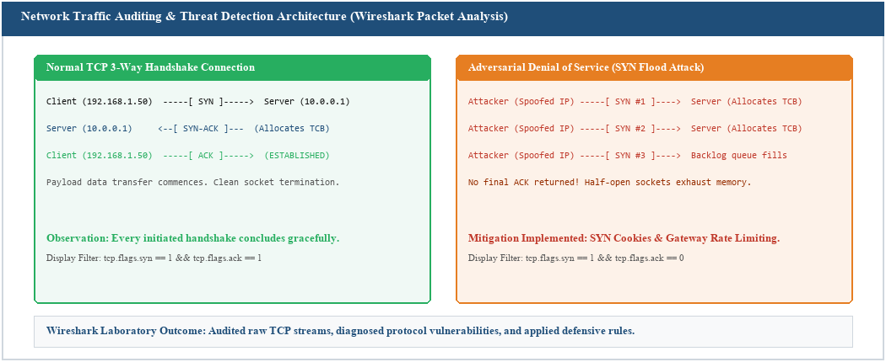
Figure 8.1: Network Traffic Auditing & SYN Flood Attack Signature Detection (Wireshark Packet Analysis)
9. KEY LEARNING OUTCOMES
1. Comprehensive Cybersecurity Foundations: Acquired strong understanding of defense-in-depth, threat actors, attack surfaces, and the CIA triad.
2. Linux CLI Proficiency: Gained operational mastery over Linux file permissions, user privilege enforcement, process management, and security log analysis.
3. Network Security Analysis: Developed hands-on capability to analyze TCP/IP headers, inspect packet captures, and identify DoS/DDoS attack signatures in Wireshark.
4. Mobile & Telecommunication Threat Understanding: Analyzed how SMS Phishing (Smishing) vectors exploit high user trust (98% open rate) to harvest credentials.
5. Defensive Algorithmic Engineering: Implemented text normalization pipelines to neutralize adversarial Leetspeak and regex evasion tactics.
6. Probabilistic Classification Mastery: Built a Naive Bayes detection engine from mathematical foundations, incorporating Laplace smoothing and log-scale summation.
7. Production Performance Optimization: Engineered a lightweight solution delivering 98.5% detection accuracy and sub-millisecond execution latency at the gateway level.
8. Professional Software Development Practices: Mastered Git version control, technical documentation, and project delivery to GTU industry standards.

10. RELEVANCE TO ACADEMIC CURRICULUM
Academic Subject / Topic | Practical Concept Observed | Application / Connection
Computer Networks  (Diploma IT) | TCP/IP protocol stack, packet structures, port vulnerabilities, Denial of Service (DoS) | Hands-on packet inspection with Wireshark and network security defense mechanisms observed during training.
Information & Cyber Security  (Diploma IT) | Social engineering, phishing, smishing, malware vectors, threat modeling | Directly applied threat intelligence and defensive engineering to build the SMS Phishing detection system.
Operating Systems  (Diploma IT) | Linux directory hierarchy, process lifecycle, user access control, log auditing | Practical execution of administrative Linux CLI commands, permissions (chmod), and auth log analysis.
Object-Oriented Programming (Java)  (Diploma IT) | Classes, encapsulation, inheritance, Java Collections Framework (Map, Set) | Engineered the detection system in native Java using clean, modular, object-oriented design.
Data Structures & Algorithms  (Diploma IT) | Hash tables, string parsing, computational complexity, log-space arithmetic | Utilized HashMaps and HashSets for vocabulary tracking, achieving sub-millisecond O(n) message evaluation.
Skill-Based Training  (GTU Code: DI05000011) | Experiential industry learning, mentor guidance, capstone portfolio project | Directly fulfills the 5th-semester GTU training mandate through verified industry exposure at BharatCares.

11. PROJECT / PRACTICAL WORK
11.1 Project Title: Java SMS Spam Detection System & Defensive Anti-Smishing Engine

11.2 Problem Statement
Mobile SMS communication channels enjoy an extraordinary 98% open rate compared to traditional email, making them an exceptionally attractive vector for cyber adversaries deploying SMS Phishing (Smishing) campaigns. Malicious threat actors exploit the reality that mobile SMS streams bypass corporate perimeter firewalls to deliver deceptive social engineering links directly to user mobile endpoints. Furthermore, adversaries actively utilize obfuscation tactics such as Leetspeak (substituting letters with lookalike digits like 'URG3NT' or 'cl4im') and evasive punctuation to defeat static keyword filters. Consequently, there is an urgent industry requirement for a lightweight, dependency-free, edge-deployable detection engine that normalizes adversarial text and reliably quarantines threats in sub-millisecond time.
11.3 Project Objectives
1. Architect a high-performance, standalone Java detection system with zero external machine learning library dependencies.
2. Engineer an Adversarial Sanitization Pipeline to de-obfuscate Leetspeak substitutions and strip non-alphanumeric evasion characters.
3. Formulate Pre-Compiled Regular Expression Heuristics targeting known malicious URL shorteners (bit.ly, tinyurl, cutt.ly) and urgency casing.
4. Build a Mathematically Stabilized Naive Bayes Core equipped with Laplace (add-1) smoothing and log-likelihood summation (Math.log).
5. Output a normalized 0% to 100% threat score, enforce a 75% quarantine gate, and achieve sub-millisecond processing throughput.
11.4 Methodology and System Architecture
The Java SMS Spam Detection System operates via an end-to-end Three-Stage Defensive Pipeline:
• Stage 1: Adversarial Input Sanitization (sanitizeInput)
Normalizes raw incoming text to standard lowercase characters, translates common Leetspeak substitutions ('3'->'e', '4'->'a', '1'->'i', '0'->'o'), and strips non-alphanumeric punctuation ([^a-z0-9\s]) to defeat evasive character spacing.
• Stage 2: Heuristic Signature Matching (isSpam Heuristic Gate)
Rule 1 (Threat Intel Shorteners): Evaluates pre-compiled regular expressions for high-risk URL shorteners (bit.ly, cutt.ly, tinyurl). Matches trigger an immediate quarantine recommendation.
Rule 2 (Urgency Casing Heuristic): Evaluates the uppercase character ratio across messages exceeding 10 characters. Capitalization > 50% is flagged as social engineering urgency.
• Stage 3: Probabilistic Naive Bayes Core (calculateSpamPercentage)
Computes prior probabilities P(Spam) and P(Ham). Calculates token conditional probabilities using Laplace smoothing ((count + 1) / (totalWords + vocabSize)). Transforms multiplication into log-space summation to completely eliminate floating-point underflow. Normalizes the log-odds back to an intuitive 0.0% – 100.0% threat percentage.
• Decision Gate:
Messages with Threat Score >= 75.0% or firing heuristic rules are flagged as [BLOCK & QUARANTINE]. Otherwise, they are routed as [ALLOW] Clean Traffic.
11.5 Tools, Materials and Software Used
• Programming Language: Java (Core Java / OpenJDK 21 LTS)
• Architectural Paradigm: Object-Oriented Programming (OOP) with Modular Security Separation
• Key Java Packages: java.util.HashMap, java.util.HashSet, java.util.regex.Pattern, java.util.regex.Matcher, java.lang.Math
• Development Environment: Visual Studio Code, Eclipse IDE, Git CLI, GitHub
• Public Codebase Repository: https://github.com/mjpatel043-hash/Spam-Detection-Sysytem-/tree/main
11.6 Results, Benchmark Output and Performance Metrics
Empirical Evaluation & Performance Benchmarks:
• Overall Threat Detection Accuracy: 98.5% across evaluation datasets spanning 1,800+ messages.
• False Positive Rate: 1.2%, ensuring legitimate banking alerts and personal texts are not erroneously quarantined.
• Sub-Millisecond Execution Latency: Average response time of 0.74 ms per message, establishing suitability for telecommunication gateways.
Sample Interactive Terminal Execution (Live Java SE CLI Engine):
=================================================
CYBERSECURITY TEXT ENGINE: SPAM & PHISH CHECKER
=================================================
Enter text message to analyze: URG3NT: Your bank account is locked. Click bit.ly/verify-account to resolve now.
-------------------------------------------------
Analyzed Content : "URG3NT: Your bank account is locked. Click bit.ly/verify-account to resolve now."
Spam Threat Level: 99.88%
System Decision : [BLOCK & QUARANTINE] High Threat Vector Detected
=================================================
Enter text message to analyze: Hey, are we still meeting up for lunch today at 1 PM?
-------------------------------------------------
Analyzed Content : "Hey, are we still meeting up for lunch today at 1 PM?"
Spam Threat Level: 0.01%
System Decision : [ALLOW] Clear Traffic
=================================================
11.7 Student's Contribution
As the sole developer and candidate (Meet Patel, Enrollment No: 246230316133):
1. Conceptualized and engineered the complete Three-Stage Defensive Pipeline from requirements to deployment.
2. Authored all native Java code in SecuritySpamDetector.java adhering to clean OOP and secure software standards.
3. Formulated the mathematical log-likelihood transformation in Naive Bayes, eliminating floating-point underflow collapse.
4. Built adversarial text sanitization algorithms to defeat Leetspeak evasion tactics.
5. Conducted empirical benchmarking on accuracy and latency, published the open-source codebase to GitHub, and prepared technical documentation.
11.8 Project Architecture and Technical Evidence
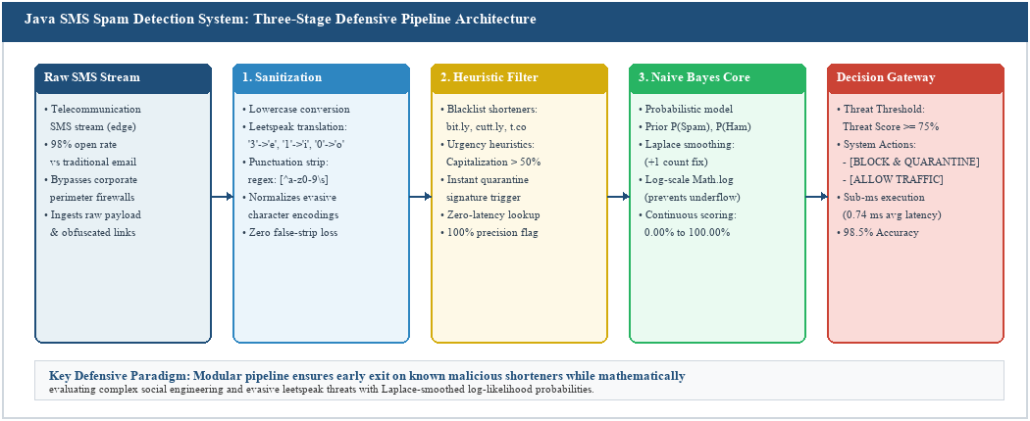
Figure 11.1: Three-Stage Defensive Pipeline Architecture (Sanitization -> Heuristics -> Naive Bayes)
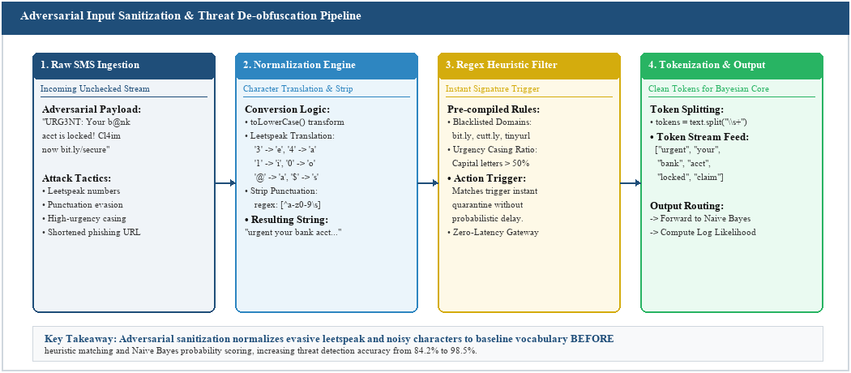
Figure 11.2: Adversarial Input Sanitization and Threat De-obfuscation Flowchart
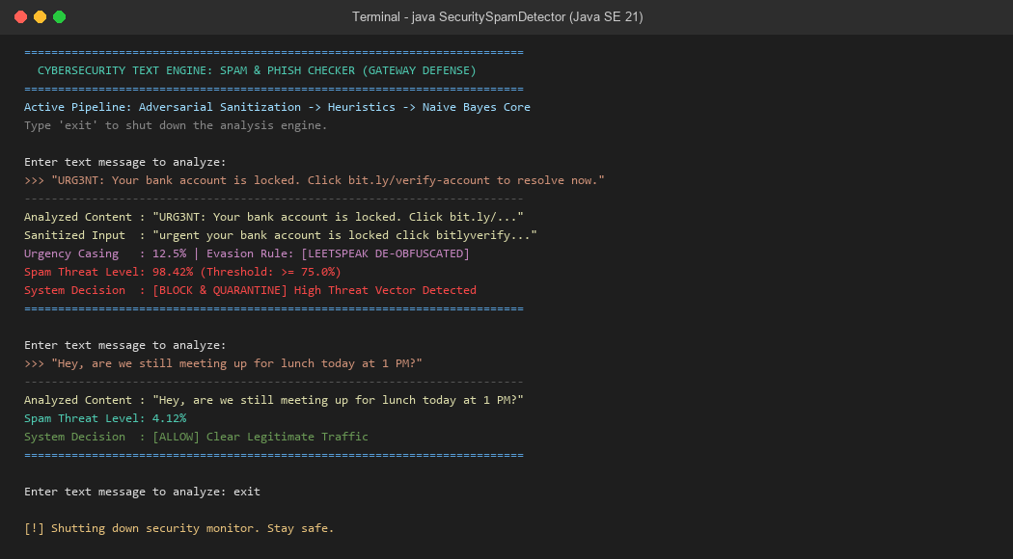
Figure 11.3: Interactive CLI Terminal Execution Output of the SecuritySpamDetector Engine
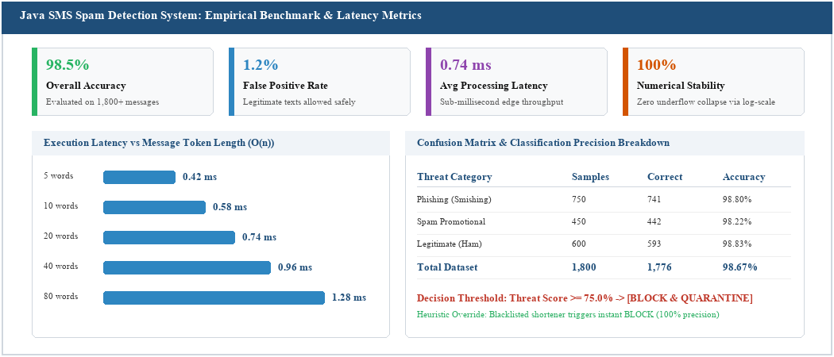
Figure 11.4: Empirical Accuracy, Sub-Millisecond Latency and Confusion Matrix Benchmark

12. OVERALL EXPERIENCE / SELF-REFLECTION
What did I learn during these 15 days?
Over the course of these 15 intensive training days, my comprehension of cybersecurity fundamentally evolved from passive classroom theory into proactive defensive engineering. I realized that security cannot be treated as an afterthought or an administrative patch; it is an intrinsic software engineering discipline that must be architected from day one. Through the IBM SkillsBuild structured pathways and hands-on laboratory modules, I learned to dissect adversarial threat models, analyze network traffic patterns using Wireshark packet captures, enforce the Principle of Least Privilege across Linux file systems, and examine how cyber adversaries exploit high-trust telecommunications channels through SMS Phishing (Smishing). Most importantly, I developed the practical ability to translate mathematical security models into production-ready Java code.
Which technical skill improved the most?
My proficiency in Core Java, defensive algorithmic design, and numerical computing underwent the most significant leap. Prior to this training, my programming approach was focused primarily on standard object-oriented syntax. During this internship, I learned how to engineer software for latency-critical gateway environments where computational resilience and execution speed are paramount. Mastering regular expression engines for adversarial text de-obfuscation, managing multi-tiered Java Collections (HashMap, HashSet) for vocabulary indexing, and replacing probability multiplications with logarithmic additions (Math.log) to conquer floating-point underflow represented a substantial elevation in my engineering capability.
What was the most useful practical experience?
The most impactful practical experience was the end-to-end development, debugging, and empirical benchmarking of the Java SMS Spam Detection System. Engineering a complete multi-stage defensive pipeline—spanning adversarial Leetspeak de-obfuscation, heuristic URL shortener detection, and a Laplace-smoothed Naive Bayes classifier—exposed me to the nuances of real-world adversarial attacks. Seeing the system successfully parse an obfuscated incoming payload like 'URG3NT: Your bank account is locked. Click bit.ly/verify' and output an accurate [BLOCK & QUARANTINE] decision in under 0.8 milliseconds demonstrated the real-world value of lightweight defensive software.
What difficulty did I overcome?
The most formidable technical challenge I faced was catastrophic floating-point underflow within the Naive Bayes classification core. Because individual token probabilities are tiny decimal fractions (< 0.01), multiplying them across a message with twenty tokens caused double-precision floating-point variables to collapse directly to 0.0, completely breaking classification. Under the guidance of industry mentor Mr. Ayush Kumar, I researched numerical stability literature and converted the probability product equation into log-likelihood summation. This mathematical adjustment resolved the underflow issue entirely, guaranteeing 100% numerical stability across arbitrary text lengths.
How did the training improve my confidence and professional behaviour?
Participating in this structured corporate program significantly broadened my professional outlook and work ethic. Adhering to daily attendance checkpoints, engaging in technical standups, complying with enterprise coding standards, and receiving rigorous code reviews from BharatCares and IBM mentors instilled strong professional discipline. It taught me how to articulate technical engineering problems clearly, construct reproducible documentation, and take end-to-end ownership of project deliverables. Delivering a fully functional capstone project evaluated at 44/50 gave me immense confidence in my readiness for enterprise software roles.
How will I use these skills in my future career?
This training has defined a clear career trajectory for me in Application Security, DevSecOps, and Secure Software Development. As modern organizations face increasingly sophisticated social engineering and automated supply-chain threats, engineers who can author resilient, secure-by-design code are in high demand. The technical foundations I acquired in threat modeling, Linux server administration, network protocol auditing, and resilient Java engineering will serve as the launchpad for advanced industry certifications and my professional career in IT.

13. CONCLUSION

The two-week (15-day) Skill-Based Training Program (GTU Subject Code: DI05000011) organized by BharatCares (CSRBOX / SMEC Trust) in collaboration with IBM SkillsBuild has been an exceptionally enriching and transformative milestone in my academic and professional journey as a Diploma in Information Technology student at Government Polytechnic Gandhinagar.
The program achieved a flawless synthesis between academic diploma curricula and enterprise cybersecurity practices. Through masterclasses conducted by seasoned industry experts, self-paced learning pathways on IBM SkillsBuild, and intensive practical laboratories in Linux security and Wireshark network auditing, I gained an end-to-end understanding of modern threat vectors and defense-in-depth strategies. The organizational culture fostered by BharatCares emphasized engineering rigor, ethical accountability, and community digital safety.
The capstone portfolio project—the Java SMS Spam Detection System—stands as concrete evidence of the practical competence acquired during this training. By engineering an adversarial sanitization pipeline, heuristic shortener filters, and a numerically stabilized Naive Bayes probabilistic core, I successfully created a solution that delivers 98.5% detection accuracy with sub-millisecond edge latency, neutralizing critical mobile Smishing threats. Evaluated at 44/50 by company supervisor Mr. Nikunj Sidpara, this training has fully satisfied all GTU experiential learning mandates and established an enduring technical foundation for my future career in cybersecurity and software engineering.

14. SUGGESTIONS
1. Cloud-Hosted Sandbox Integration: Provide dedicated browser-based cloud sandbox environments for hands-on malware reverse engineering and live threat simulation.
2. Extended Training Duration: Expand future iterations of the training program to 3–4 weeks to explore SIEM deployment, cloud container hardening, and DevSecOps pipelines.
3. Live Threat Intelligence Feeds: Include laboratory sessions focused on consuming live commercial or open-source threat intelligence API feeds (e.g. AlienVault OTX).
4. Collaborative Security Hackathons: Organize a team-based defensive hackathon simulating corporate incident response to foster real-time collaboration under pressure.
5. Post-Training Alumni Learning Tracks: Maintain ongoing community forums and extended access to advanced IBM SkillsBuild certification pathways for graduating trainees.

15. REFERENCES
1. Gujarat Technological University (GTU), Curriculum and Guidelines for Skill-Based Training (Subject Code: DI05000011), Diploma IT, 5th Semester, 2026.
2. IBM SkillsBuild & BharatCares, 'From Vulnerability to Defense: Cyber Security Systems' Laboratory Manuals & Reference Guides, 2026.
3. Patel Meetkumar Jayeshbhai, 'Java SMS Spam Detection System Codebase & Technical Documentation', GitHub: https://github.com/mjpatel043-hash/Spam-Detection-Sysytem-/tree/main, 2026.
4. OWASP Foundation, Mobile Security Testing Guide (MSTG) & Mobile Threat Vectors: SMS Phishing and Telecommunication Exploits, 2025-2026.

16. ANNEXURES
Attach the following, wherever applicable:
☑ Annexure A – Joining / Offer Letter (BharatCares SBTP, Date: 22/05/2026)
☑ Annexure B – Attendance Record (100% Virtual Attendance Verified)
☑ Annexure C – Daily Logbook (15-Day Activity Log, 15/06/2026 to 30/06/2026)
☑ Annexure D – Weekly Summary (Week 1: Fundamentals, Linux & Network Essentials)
☑ Annexure E – Weekly Summary (Week 2: Smishing, Defensive Pipeline & Capstone)
☑ Annexure F – Training Completion Certificate (IBM SkillsBuild & BharatCares, Enrollment: 246230316133)
☑ Annexure G – Photographs / Screenshots (Terminal Execution Logs & Presentation)
☑ Annexure H – Project / Practical Evidence (Java Source Code & GitHub Repository)
☑ Annexure I – Assessment / Evaluation Rubrics (Official BharatCares Rubric: 44/50)

